|  |  |  |
| --- | --- | --- |
| **LAB 321Assignment** | **Type:** | **LongAssignment** |
| **Code:** | **J3.L.P0061** |
| **LOC:** | **400** |
| **Slot(s):** | **10** |

**Title:** Managing Meal Order

**Background**

Restaurant provide services that customer can order a party online

**Program Specifications**

Program a web site display list of order which has order by customer

**Features:**

This website contains following main functions

* Function 1: Search Orders
  + The orders will be searched by order code
  + The order list must be paging
* Function 2 Display Order Details

Database description

* Database must contain order detail information displayed on the screen

***Expectation of User interface:***

**PIC 1: Order List**

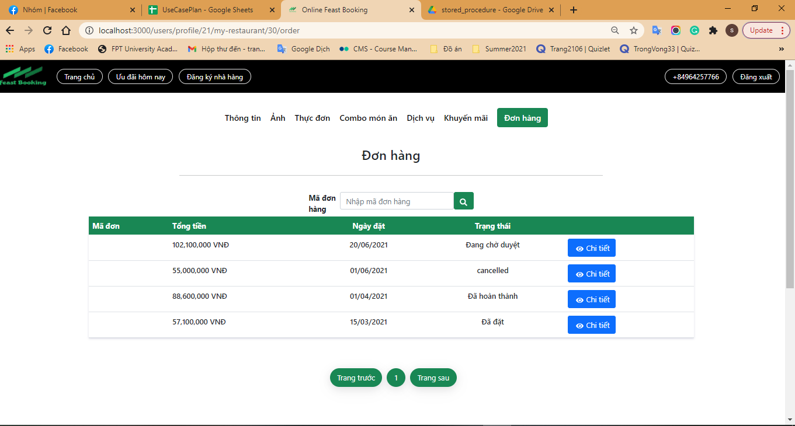

**Note: The following fields must be displayed**

1. Order code
2. Total value
3. Order Date
4. Status
5. Previous/Next button
6. Detail button : When user click on “Details” button, the system will display the Order Detail page as P**IC02**
7. Input Search field. When user click on “Search” button, the system will search all orders which match order code

**PIC 2: Order Details**

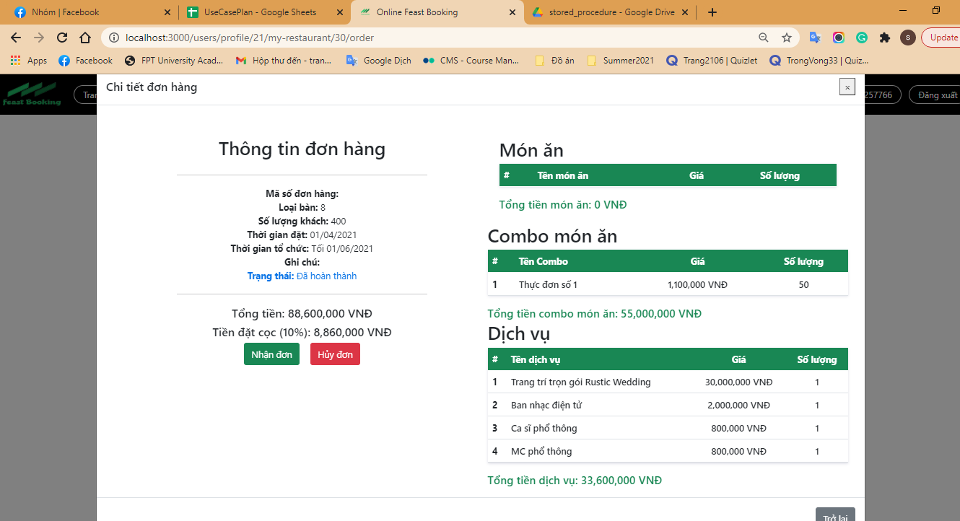

**Note: The following fields must be displayed**

1. All fields in the screen must be got from database
2. When user click on “Accept”, the order will be updated with “accepted” status
3. When user click on “Cancel”, the order will be updated with “cancelled” status
4. When user click on “Back”, the order list will be displayed

**Guidelines**

* Step 1 : Create web layout
* Step 2 : Create prototype
* Step 3 : Design database base on created prototype
* Step 4 : Code & Test